**CRM APPLICATION FOR Jewel MANAGEMENT (DEVELOPER)**

**COLLEGE NAME**: SHRI NEHRU MAHA VIDYALAYA COLLEGE

OF ARTS AND SCIENCE.

**COLLEGE CODE:** BRU 26

**TEAM ID:** NM2025TMID20725

**TEAM MEMBERS:**

TEAMLEADER**:** **USHA.S**

**EMAIL**: usha150105@gmail.com

TEAMMEMBER: **VISHNU R.K**

**EMAIL:**  vishnurk.honorview10@gmail.com

TEAMMEMBER**: NAVEEN KUMAR.U**

**EMAIL:**  naveenkumarudhayakumar@gmail.com

TEAMMEMBER**: KEERTHANA.A**

**EMAIL:** keerthanayuva521@gmail.com

* 1. **INTRODUCTION**
  2. **PROJECT OVERVIEW**

The Jewellery industry requires efficient management of customers, sales, inventory, and services. A **CRM (Customer Relationship Management) application** helps jewellery businesses streamline operations, maintain customer relationships, track sales, manage stock, and provide personalized experiences.This project focuses on building a **CRM application tailored for jewellery management**, providing a centralized platform for handling customers, employees, suppliers, and business activities.

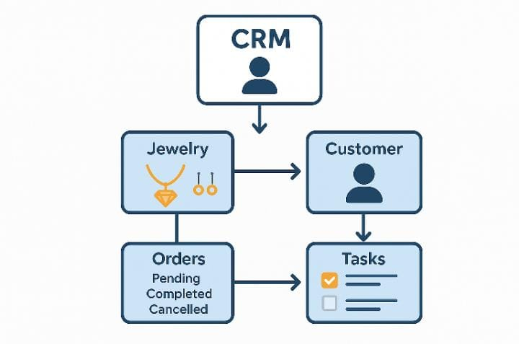

* 1. **PURPOSE**

The purpose of this project is to **streamline jewellery business operations** by providing a centralized **CRM solution** to manage customers, sales, billing, inventory, suppliers, and employees. It helps jewellery stores improve **customer relationships, reduce manual errors, track stock effectively, and generate real-time reports** for better decision-making and business growth.

**DEVELOPMENT PHASE**

**CREATING DEVELOPER ACCOUNT:**

By using this url: <https://www.salesforce.com/form/developer-signup/?d=pb>

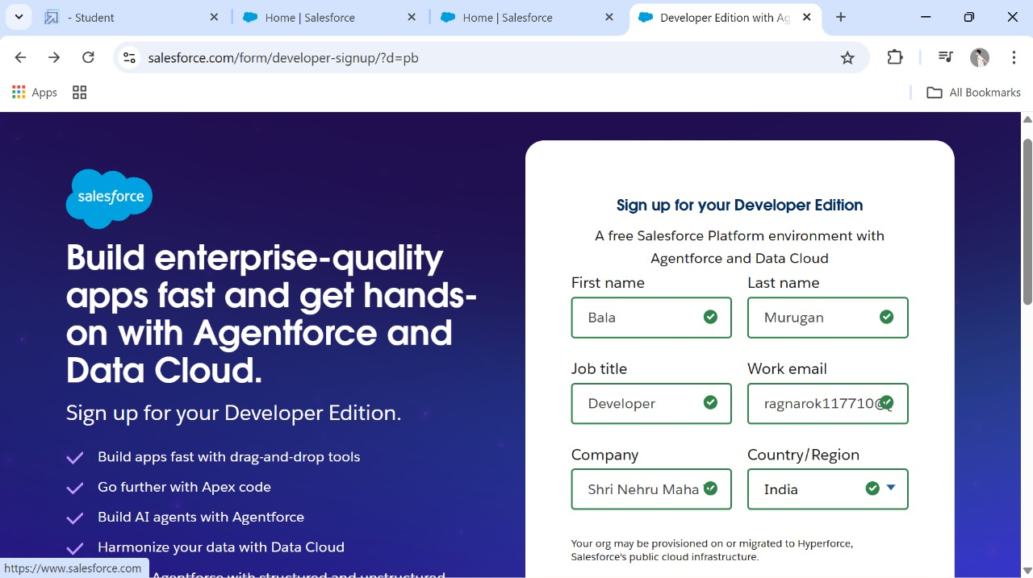

**Create a jewel customer object**

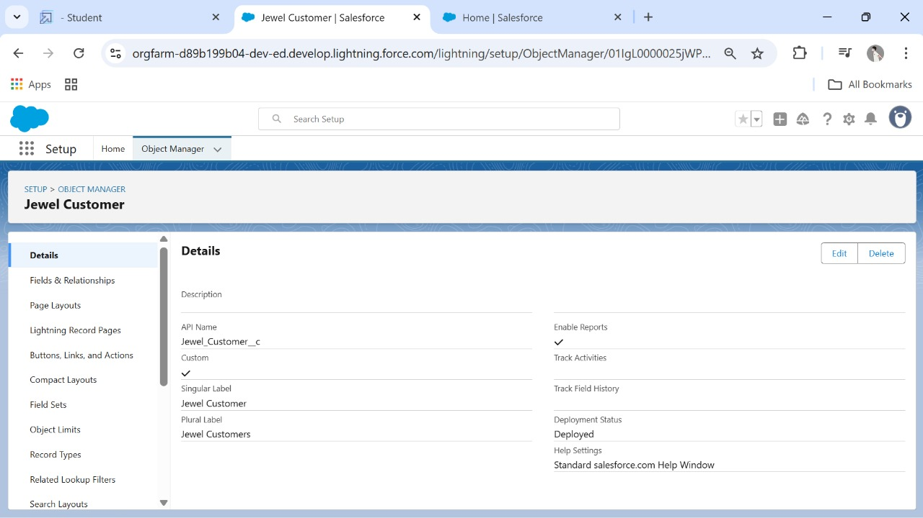

**OBJECTS**

CREATED OBJECTS:

* **ITEMS**
* **BILLINGS**
* **PRICES**
* **CUSTOMER ORDER**

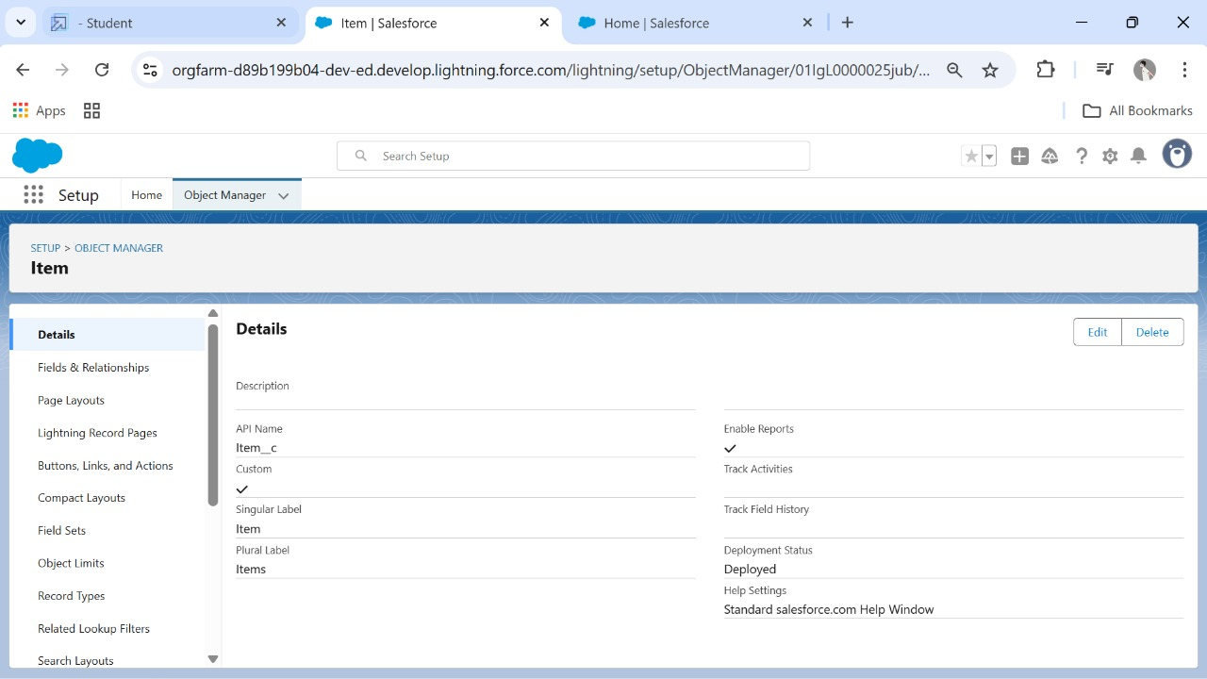

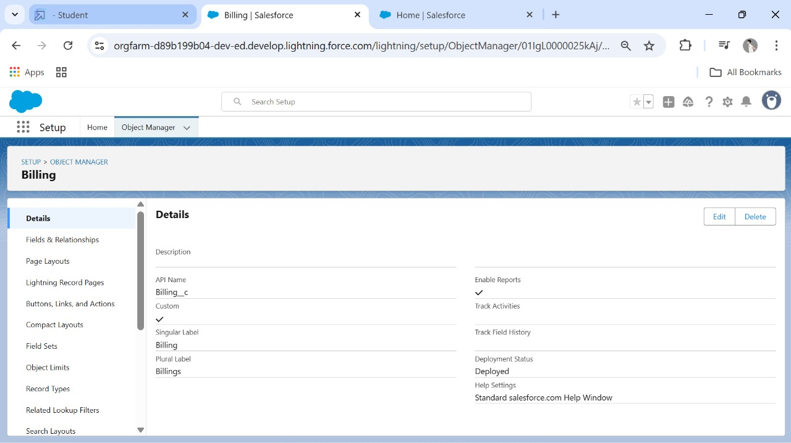

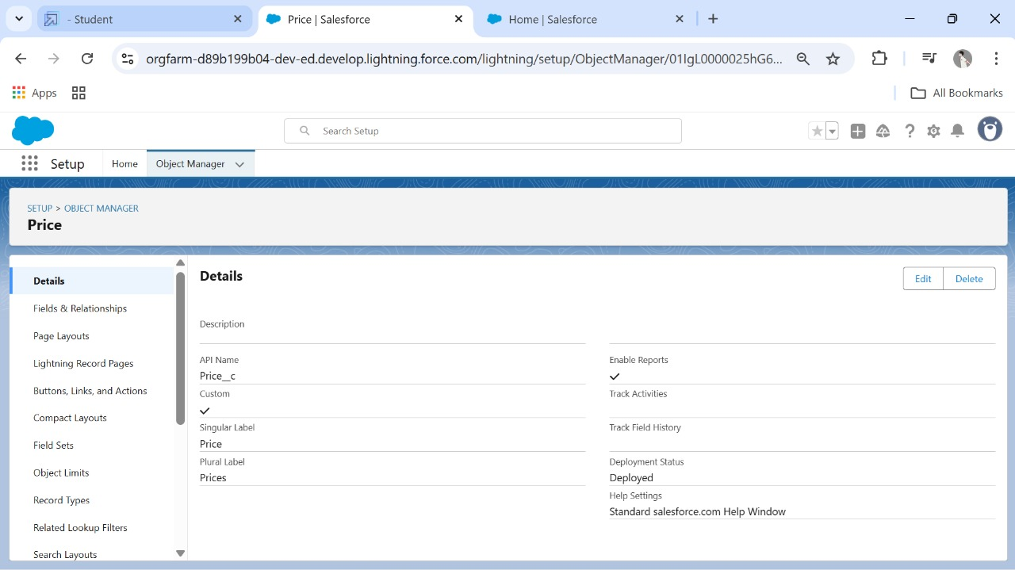

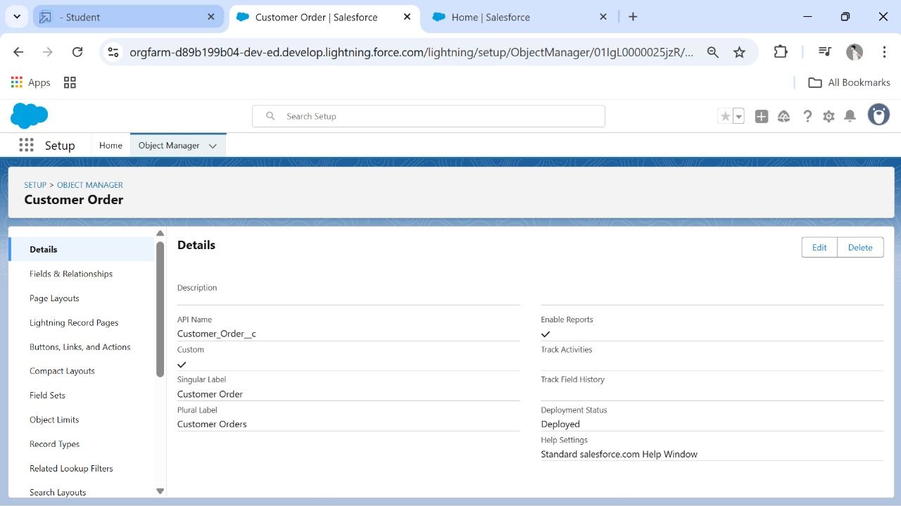

**CREATED TABS:**

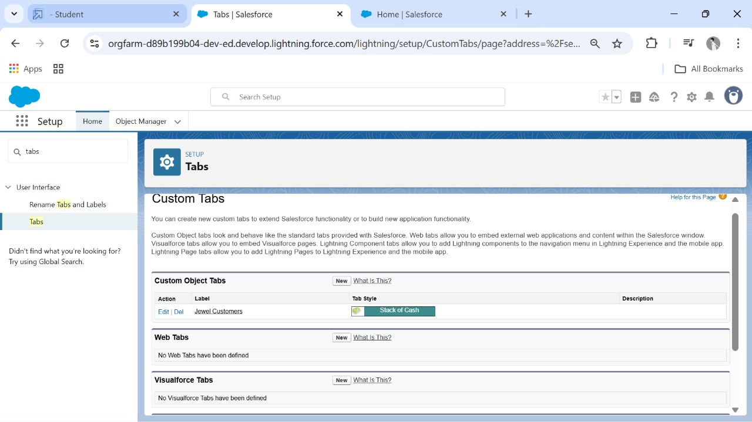

**Created A Tab:**

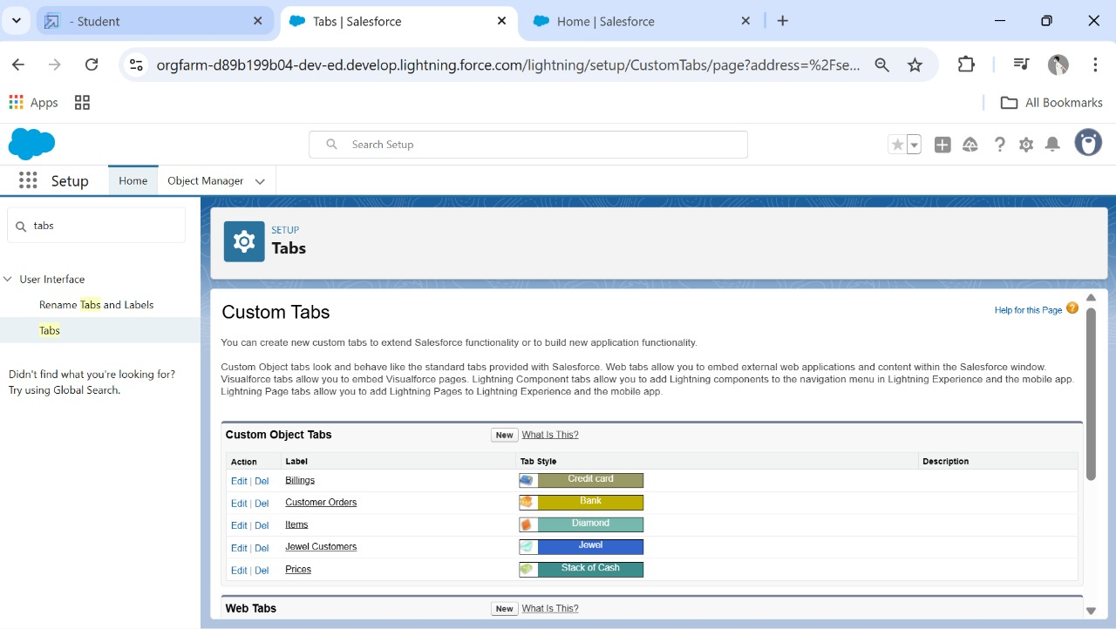

**Created A Lightning App:**

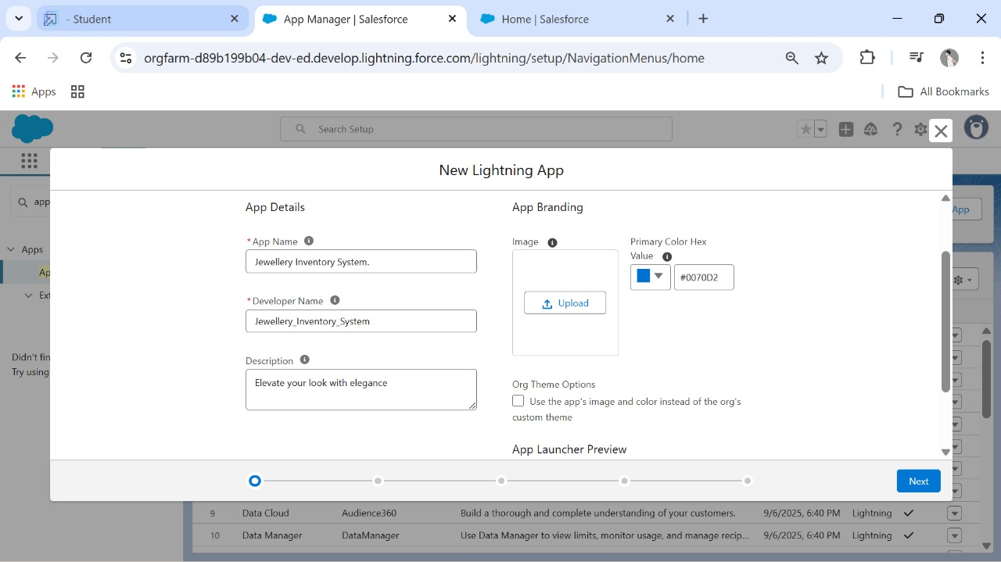

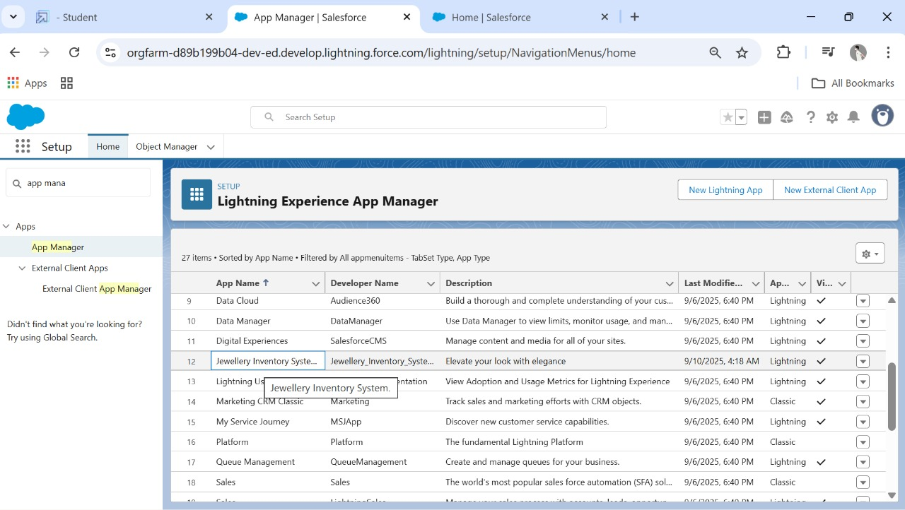

**Created Lookup Relationship:**

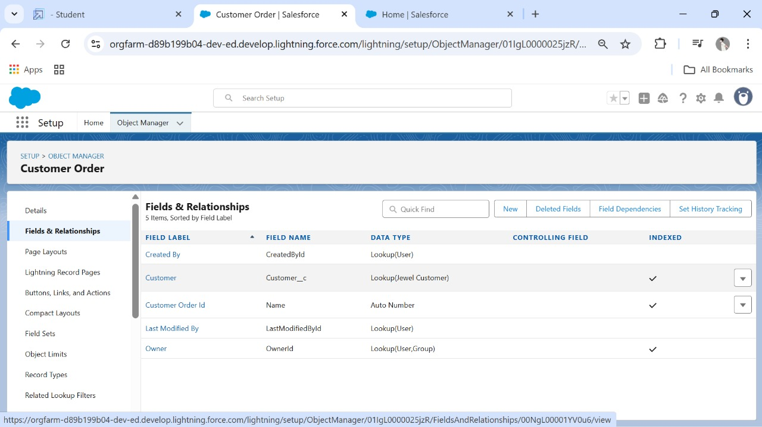

**Created Text, phone, Email Field In Jewel Customer Object:**

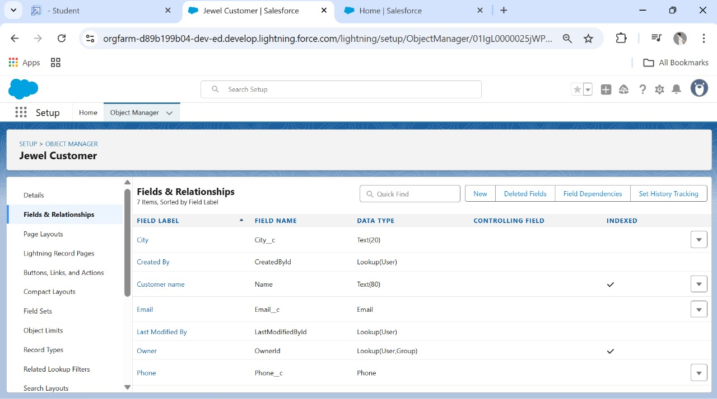

**Created The Number, picklist Field In Item Object:**

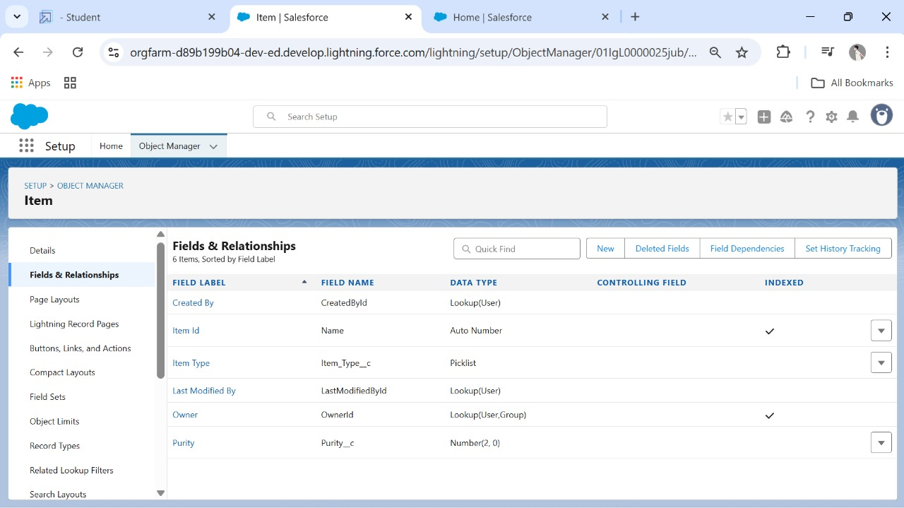

**Created Currency Field In Price Object:**

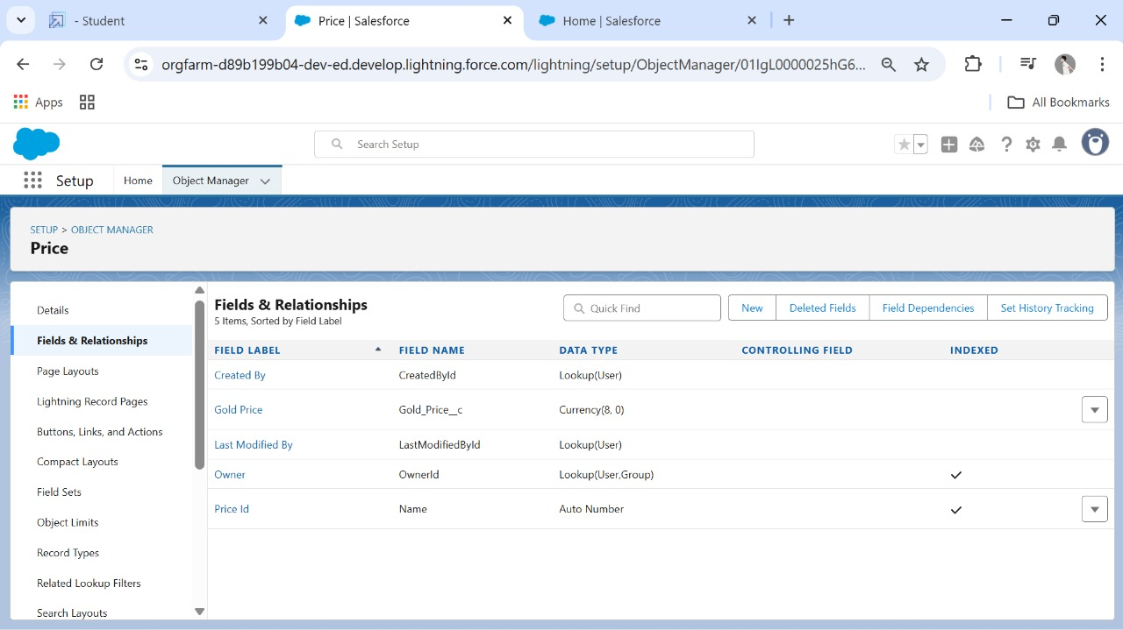

**Created Formula Fields:**

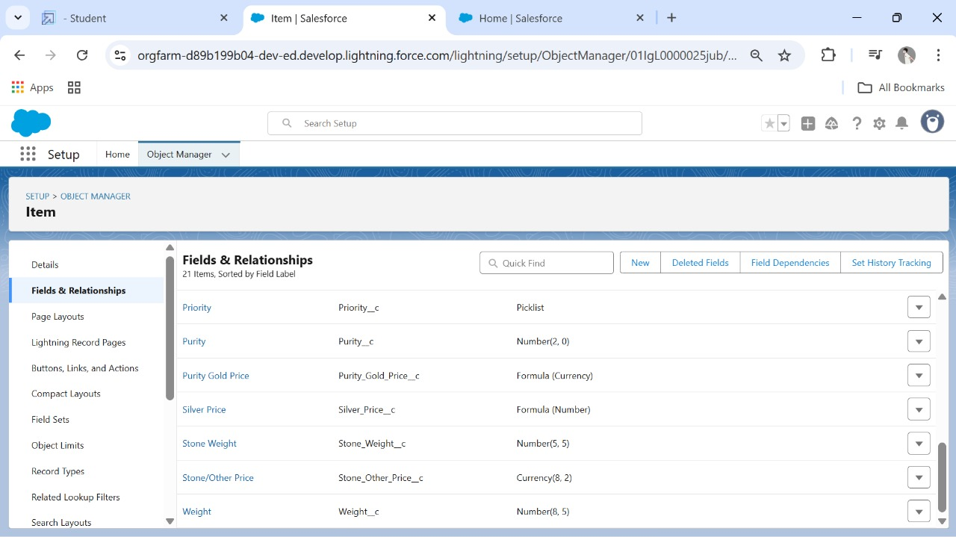

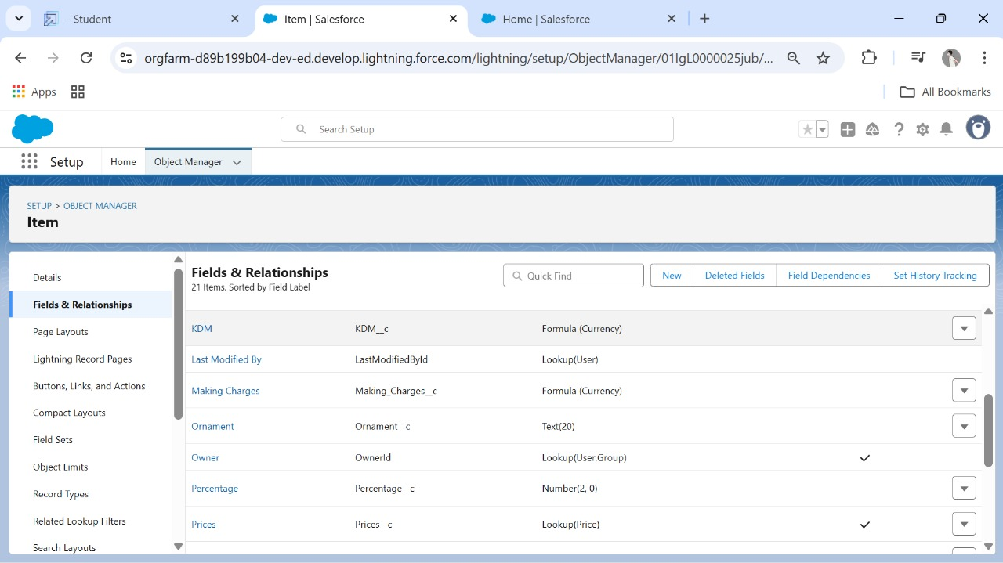

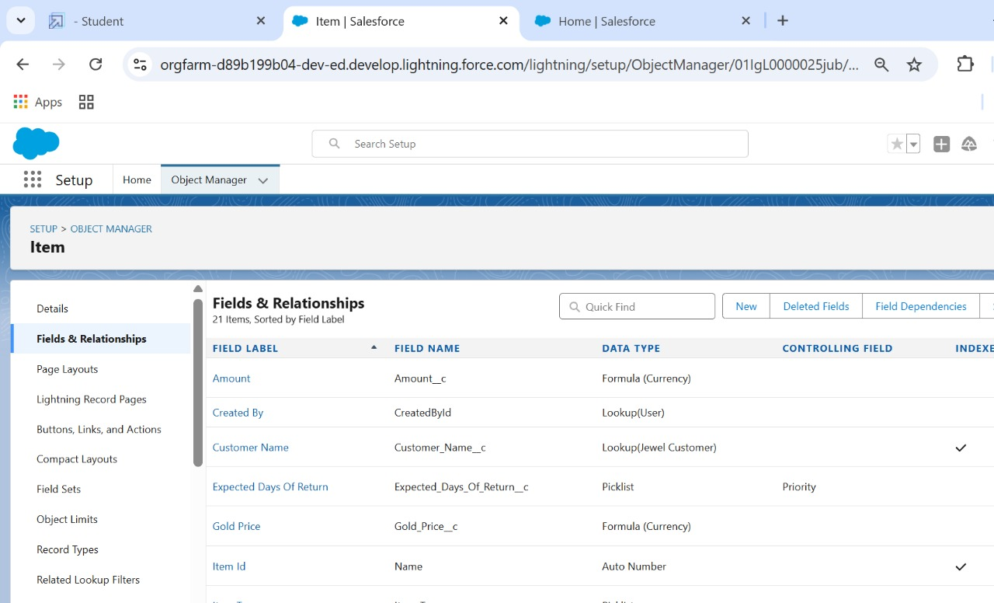

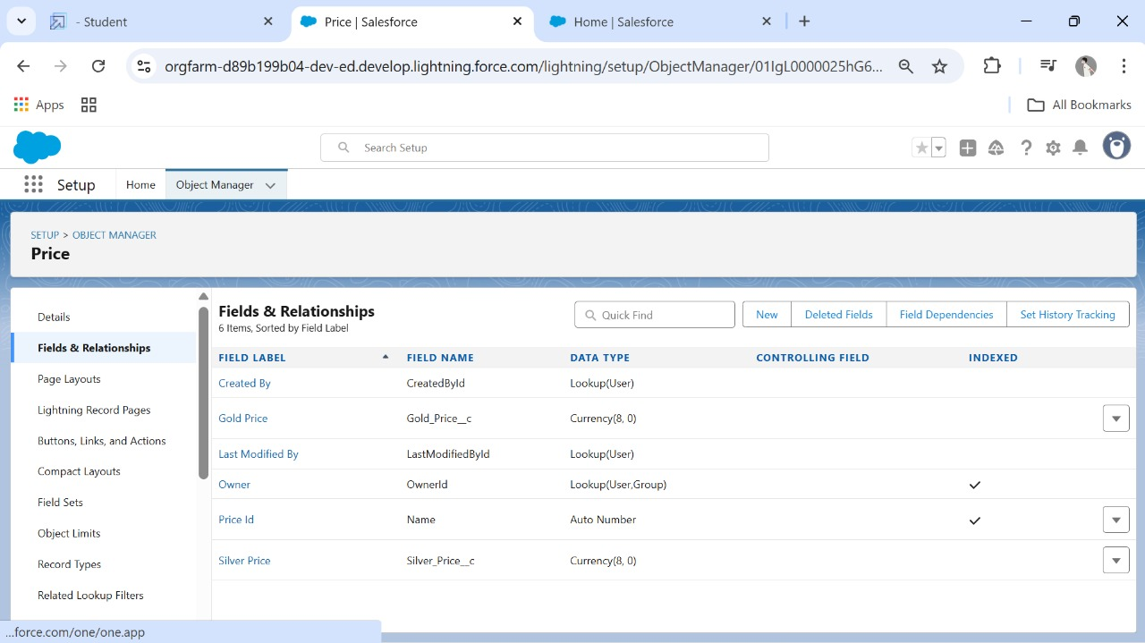

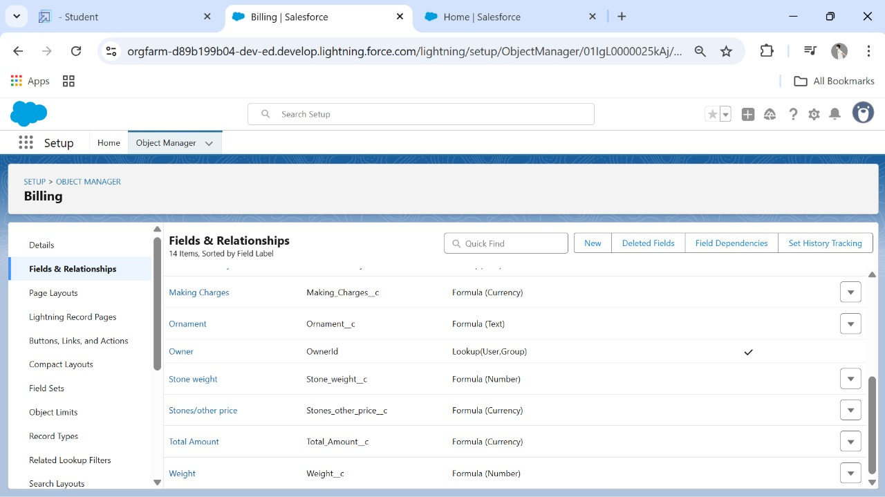

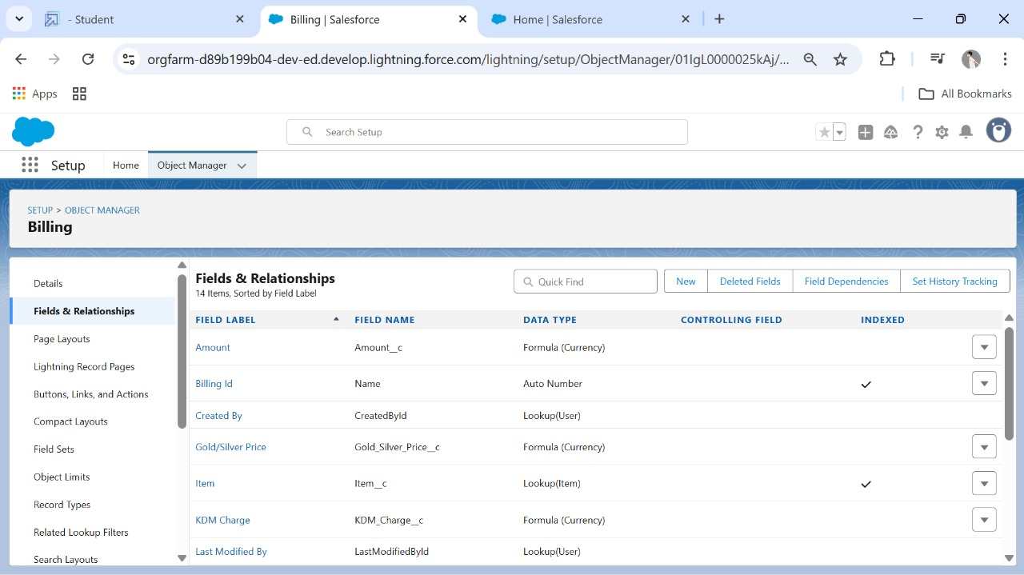

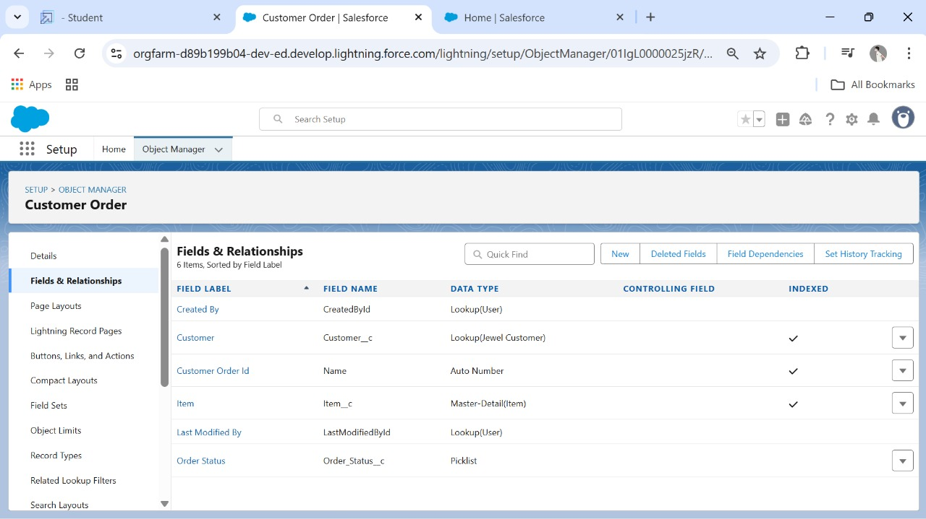

**Created The Field Dependencies** :

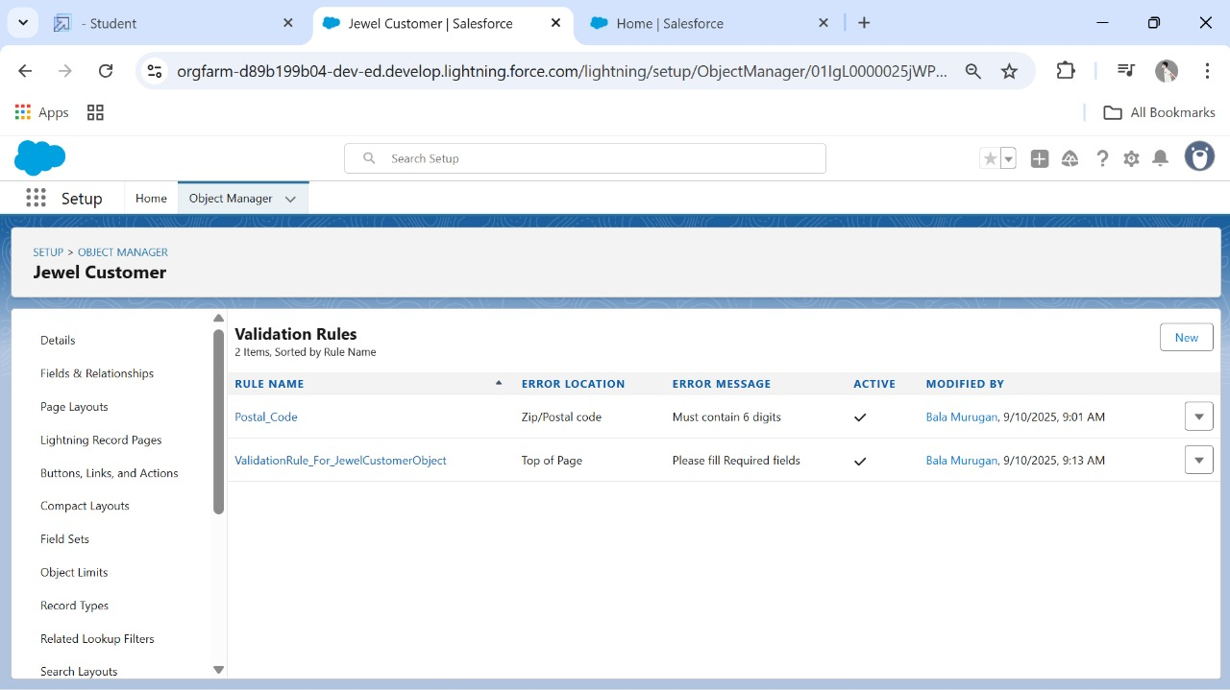

**Created The Validation Rule:**





**Profiles:**

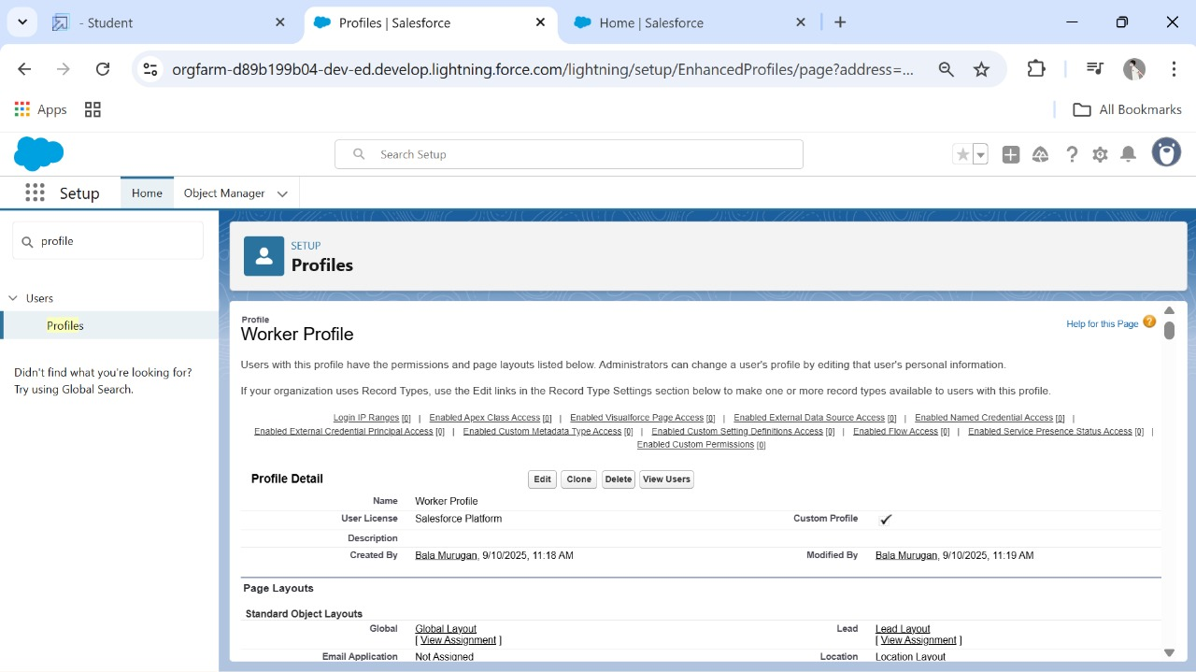

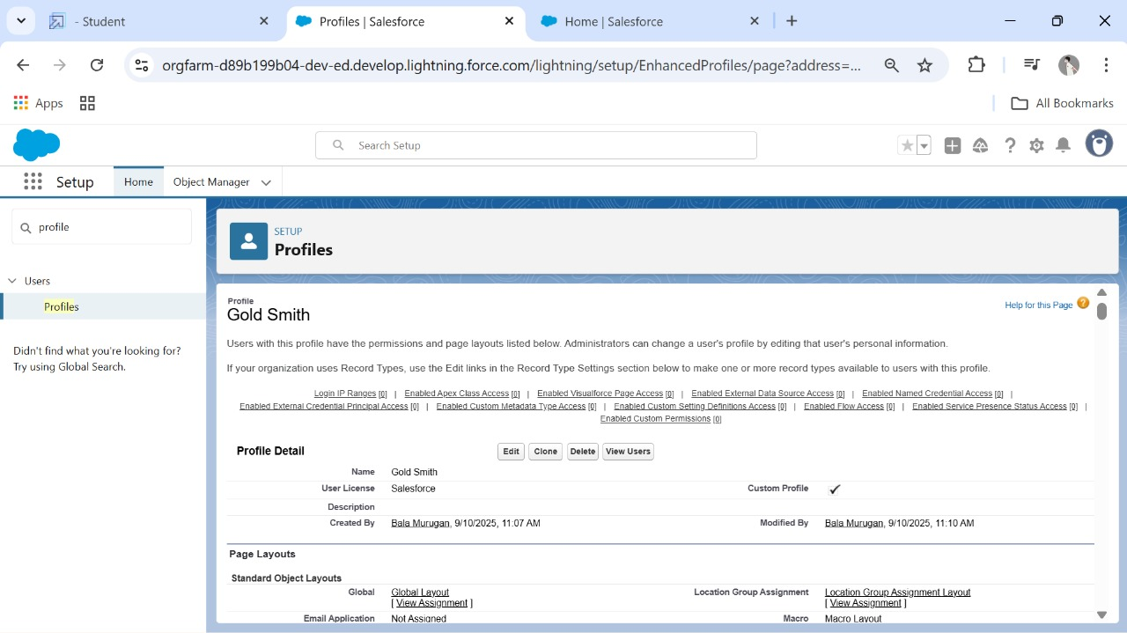

**Roles:**





**Users:**

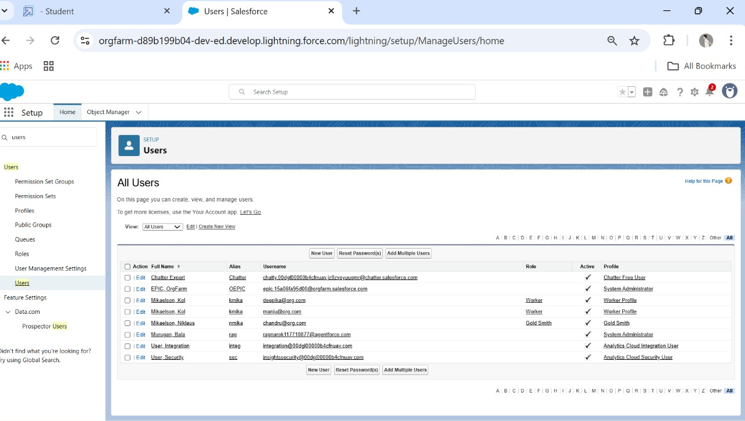

**Page Layouts:**

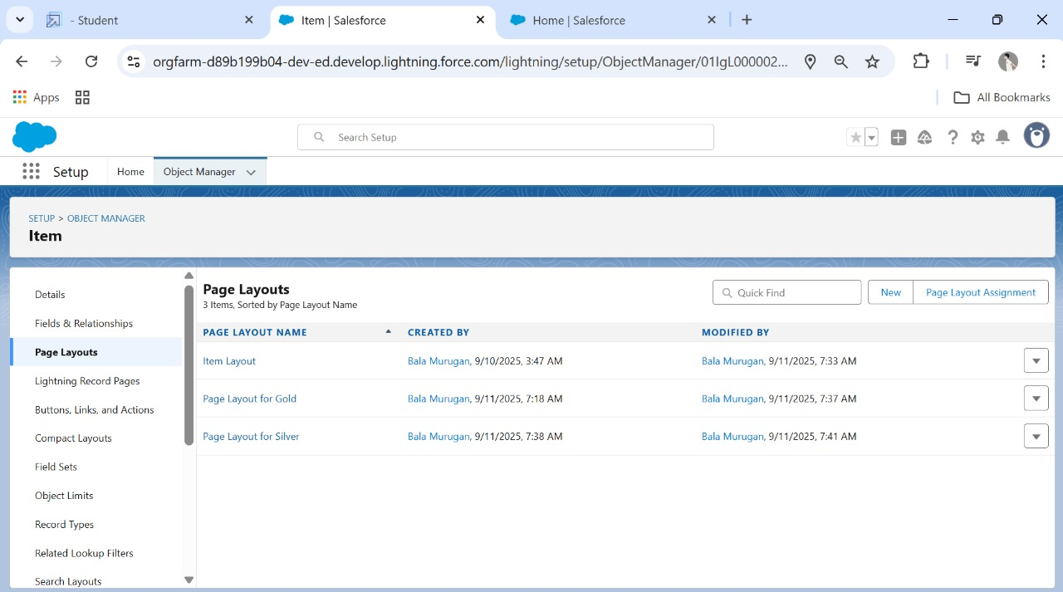

**Record Types:**

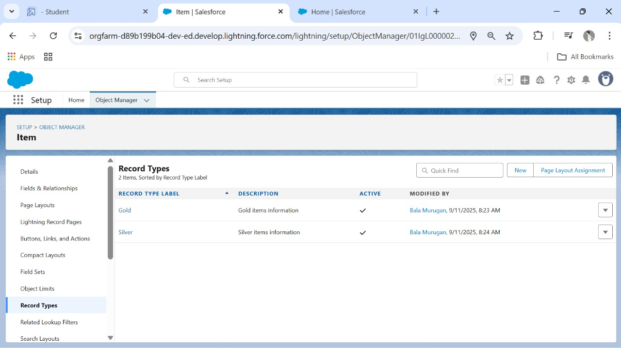

**Created Permission Set:**

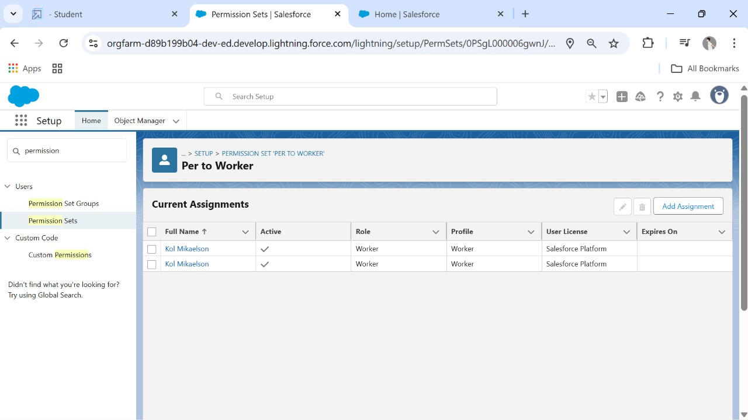

**Created A Trigger Handler Class:**

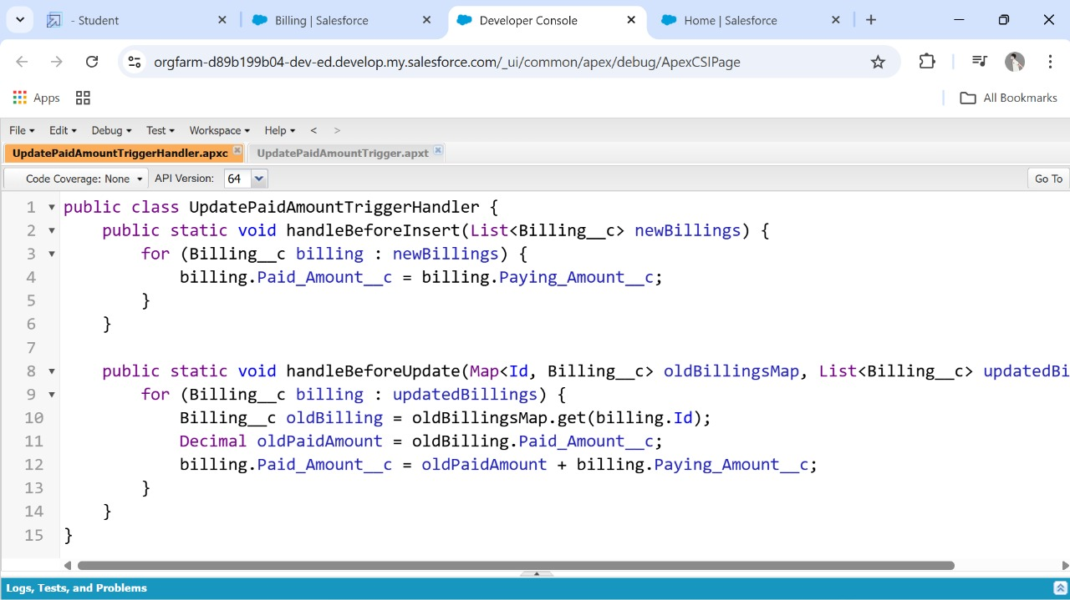

**Create The Trigger:**

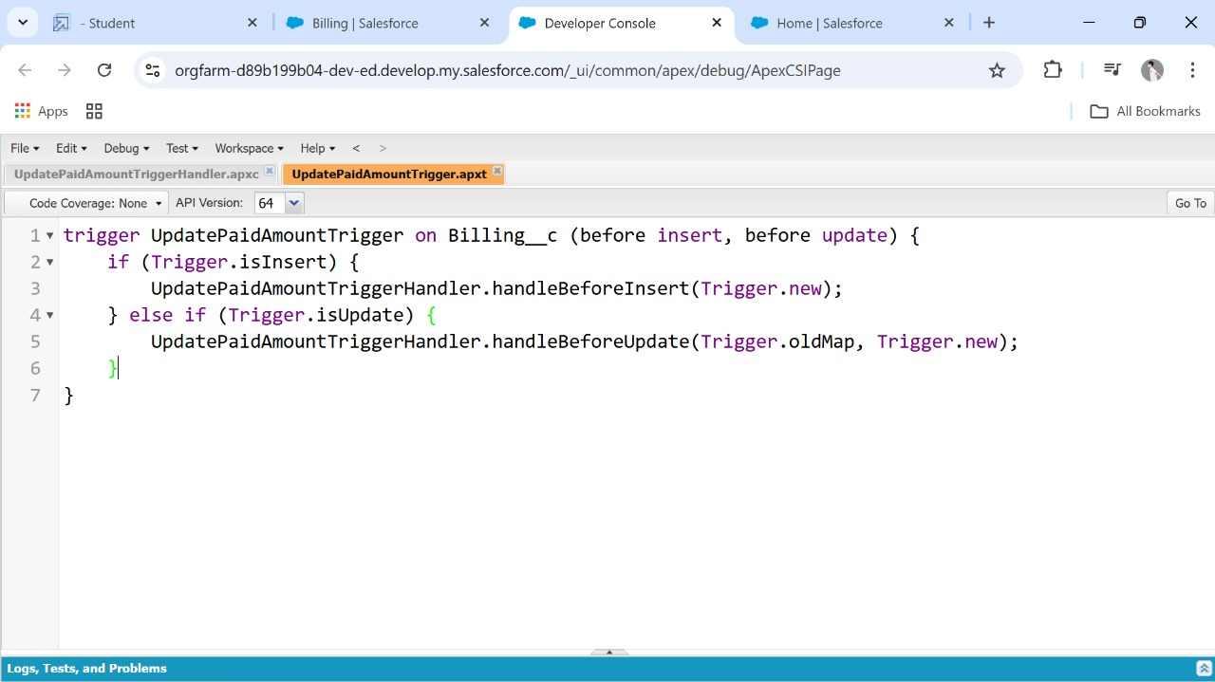

**User Adoption, Reports, Create Dashboard:**

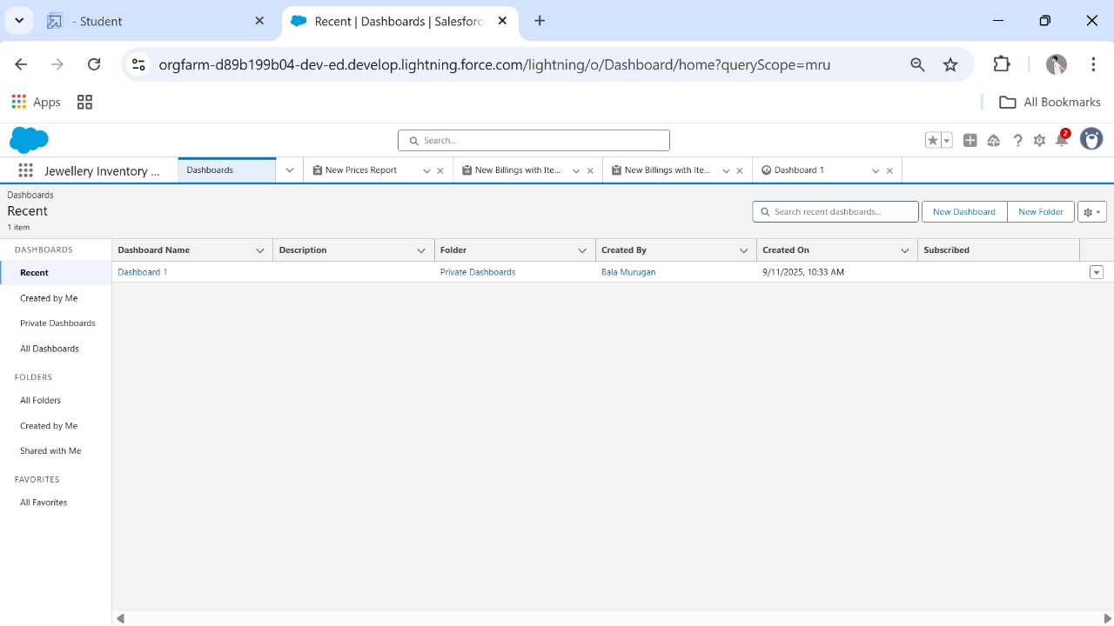

**Created Flows:**

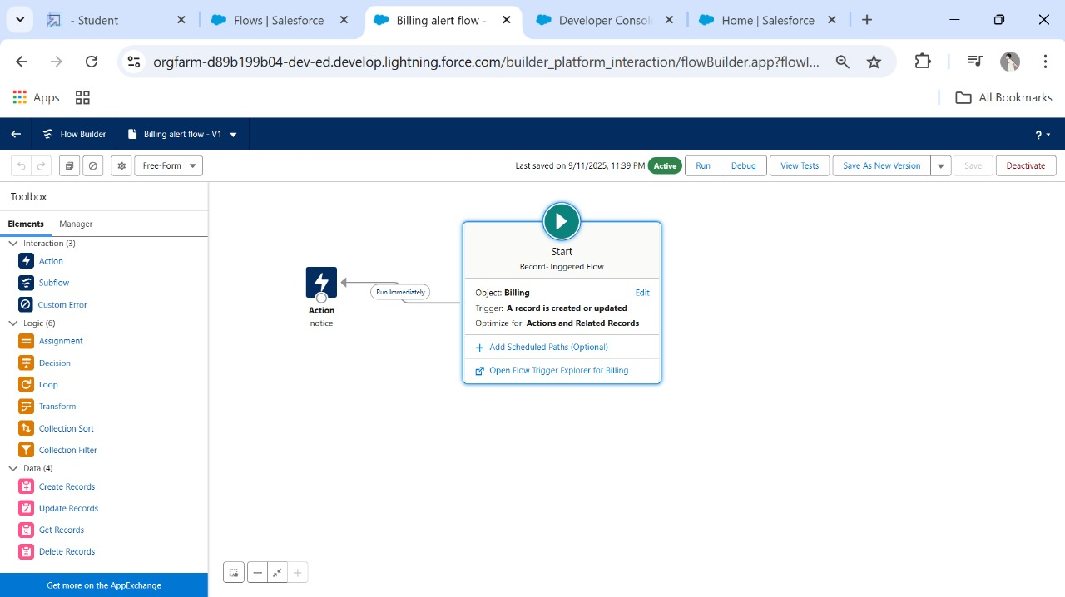

**CONCLUSION:**

This project leverages Salesforce CRM to provide a cloud-based jewellery management system. It integrates customer relationship management with sales and inventory, helping jewellery businesses improve efficiency, profitability, and customer engagement.